
FNHGL
2026
Friday Night Hackers
Golf League
Rules & Bylaws
Friday Night Hackers League Membership Requirements -
Membership is open to any and all interested players of any skill level. This is a weekly, 9-Hole League (although many elect to play a full 18 holes), with rates, and “bank scoring” info as shown below.
Where Do We Play? –
Ponderosa Golf Course - Hookstown, PA - Phone: 724-947-4745 http://www.ponderosagolfcourse.com/
How Much? – Annual League Membership Dues - $80.00
(Please Note – This is required to be paid by the 1st league outing on June 27th). All funds go towards skill prizes at the monthly outings (which typically includes a dog and beverage at the turn for the first 3 outings), along with the end of season banquet costs, season results and raffle prizes at the final outing. That being said, your league entry fees do not cover any green fees for the regular season, nor any of the four outings.
- If you’re already an avid Zelle user, you can simply Zelle $80 to wjreinehr@comcast.net and I’ll take care of the rest in moving that money into the golf league credit union account for you.
- For those members who have an account at the Bayer Heritage Credit Union and use on-line banking:
- Select “Transfers & Payments”
- Select “To Another Member” under the Other Options
- Select your account the money will come from
- In the Select Payee drop-down, you can pick “League” if you have saved the league account as a payee in the past, or if not, select “+ Add New Payee”
- Add New Payee Details:
  - League Account Number is: 20006001
  - Last Name on the League Account is: League
  - The Share/Loan ID is: S:0000
  - Amount to transfer is: $80.00
  - Memo for this transfer: “FNHGL Dues for your name here”
  - Click “Transfer”, and you’re done!
- If you have an account at BHFCU, but do not use on-line banking, you may call and request an $80.00 transfer: Bayer Golf League (Acct #20006001 ~ S:0000 - Savings). BHFCU Phone: 800-272-6003
- As the credit union building will sadly be no more by the time the season starts, I’d like all other league dues payments to be made in cash to me, and I’ll handle the rest of the transfer as if you had Zelled me directly. Whether it be at the pro-shop, the 19th hole, or at the first outing, PLEASE put the money in an envelope (or at least put a post-it note on it) with your name, to help me keep the books straight.
Weekly Greens Fee – (*These rates have not yet been confirmed for the 2026 season, but should be close).
9 Holes Walking: $18.00 ----- 9 Holes Riding: $24.00
18 Holes Walking: $20.00 ----- 18 Holes Riding: $32.00
(These league rates are generally limited to 1:00 PM or later on Fridays, and calling in advance to ensure there is no conflict with an outing is highly recommended).
When Do We Start? –
Practice rounds are slated to begin on Friday, April 3rd, with official scoring to begin on Friday, April 24th. All practice rounds are optional, but you may use your practice rounds for future bank scores as necessary, and they will also serve as base scores for any newbies needing to establish a handicap. Barring rainouts, we will play every Friday, with official scoring running from April 24th to September 11th.
League Format – NEW SCORING FORMAT FOR 2026
We play 9-holes each week, alternating front to back 9’s, with points awarded based upon a Modified Stableford Scoring Method: To an extent, this is only for your informational purposes as to how the weekly points will be calculated this year, and I do not expect everyone to be doing long math each week… PLEASE – Simply enter your scores each week as you normally would, (with your gross scores for each hole), as I have already written the Excel spreadsheets to calculate the resulting points for us.
Point System –
- Double-Bogey or Worse (2 or more Over Par) = -1 Point
- Bogey (1 Over Par) = 0 Points
- Par (Even) = +1 Point
- Birdie (1 Under Par) = +2 Points
- Eagle (2 Under Par) = +3 Points
- Double-Eagle or Better (3 or more Under Par) = +5 Points
In general, Men play from the White Tees, Seniors from the Gold Tees, and Women from the Red, but you are free to play the from the Tips (Blue Tees) and/or also change Tee Boxes from week to week as well if you wish. *Please ensure that you denote which tee box you played on your scorecards so that your point results are based on the proper slope/rating values accordingly.
Important Scoring Note: All “Newbies” to the league must have at least two 9-hole scores from Ponderosa submitted to create a basis for their handicap before you can accrue any weekly points. If any Newbie happens to have a legitimate GHIN handicap they can provide, the 2-round requirement will be waived. All returning league members will begin with their closing handicaps from last season, (which will be updated to the current World Handicap System standards as applicable).
With the transition to the Modified Stableford Scoring System, we will no longer have the historical 4-flight (A-B-C-D) system, and everyone will effectively be playing against the course each week with their own respective handicap, and the resulting point standings will span the entire league from first to last place.
Submitting Scores -
PLEASE include FULL NAME and TEE BOX USED for each player, along with the DATE that the round was played (or banked date as applicable) on the scorecard!!
- As our scoring system now accrues points on a hole-by-hole basis, PLEASE do your best to write legibly.
- Scores must be Emailed no later than Tuesday of the following week after each Friday night round. Simply take a picture of your scorecard and send it to fnhglscorecards@gmail.com.
Banking Scores –
Understandably, business travel and/or vacations might conflict with playing on a given Friday – Not a problem. You may “bank” a score for any given week that you know you will not be able to attend. I cannot guarantee that the course will extend our league rates to you on a non-league night, but you may play at any time.
- NOTE: We alternate from playing the front-9 to back-9 each week, and since they are different pars, you must make sure that your “banked” score is played on the respective side for the week that you need. It is up to each player as to how they want to handle their own “bankable” scores… You may hold onto all of your scores and submit them only as needed, or submit each and every score as you play. In the case of the latter, we will be using the “First-InFirst-Out” sequence of applying the respective scores, (again – keeping the proper side in mind while doing so).
Rainouts –
We must have at least a 25% attendance rate for any given week to count. If you happen to submit a score for a given week that ends up being deemed a rain-out, you may either retain that score as a bank, or you can request it to be discarded, via an Email to fnhglscorecards@gmail.com.
Here’s an excerpt of the scoring calculations for this season…
- Each week, your own handicap, based upon the tee box used, and the respective side to be played will be distributed per the course handicap values for each hole.
- Your Gross score values are entered into the spreadsheet, and automatically revised if/as necessary to meet the max score of Net-Double-Bogey in the Adjusted Gross row.
- Your Net score per hole is then calculated, and used to determine your Points awarded (or subtracted), based on the table shown on the previous page.
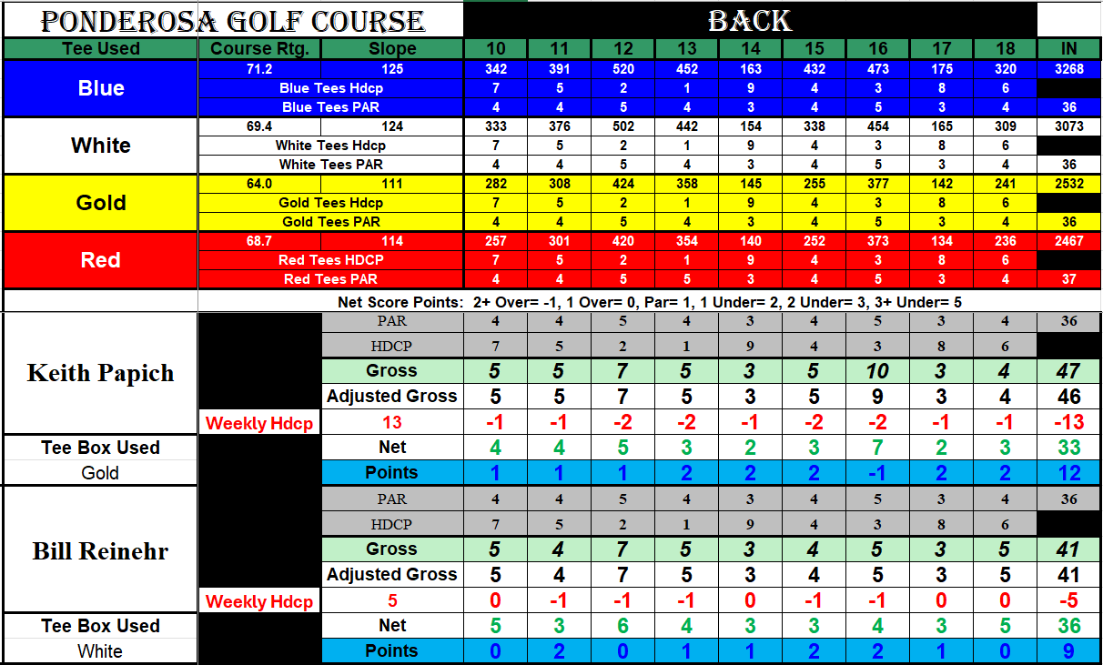
Tee Time Considerations –
Our league tee times were historically considered to begin at 4PM, but through the years this has become a moot point (perhaps for both the good and the bad of our league’s interests…). Thus - you are certainly not restricted to starting at 4PM or later, but likewise, the course also has the right to allow non-league players out past 4PM as well. To be fair, they try to give our league precedence over any walk-on’s after 4PM, but I highly suggest calling for a tee time @ (724) 947-4745 when planning to play prior to 4PM, and a few groups simply make standing tee-times for the entire season.
League Standings & League Website -
http://fnhgl.yolasite.com/. This site will provide a central point of info for league standings throughout the year, details for upcoming league events, and other News & Notes along the way.

Monthly Outings:
Date | Course | Format
June 27th  10:00 AM | The Links at Firestone Farms  105 St Andrews Dr  Columbiana, OH 44408 | Individual Callaway  (You can pick your own foursomes)  CTPS: #2, #8, #15, #17, LD’s #9, LP #18
July 18th  11:00 AM | Lindenwood Golf Course  360 Galley Road  Canonsburg, PA 15317 | 2-Person Team Scramble  (You can pick your own teams)  Skill Prizes TBD upon confirmation of 9’s being played
August 15th  10:04 AM | Fox Run Golf Course  4240 River Rd  Beaver Falls, PA 15010 | Shamble ~ (Take best drive and play your own)  (You can pick your own foursomes)  CTPS: #6, #9, #11, #15, LD’s #9, LP #18
September 19th  10:08 AM | Reserve Run Golf Course  625 E Western Reserve Rd  Poland, OH 44514 | Pink Ball Classic  (You can pick your own teams)  CTPS: #2, #8, #15, #17, LD’s #9, LP #18
Closing Notes & General Governing Rules – All USGA Rules apply, with the following important exceptions:
We use a simplified “equitable stroke control” variance from the rules wherein the maximum score on any given hole is double par (the official max of net double-bogey will automatically be handled during score processing). If you find yourself putting (or praying for a chip-in) to make double par, please pick up your ball, try to recoup whatever dignity you may have left, and move on to the next hole to keep on truckin’.
If you hit out of bounds or into the drink, you may treat these as lateral hazards: Just drop at that location, no closer to the hole, with 1 stroke penalty, and move on from there. Please observe proper etiquette on pace of play, and take care of the course as best you can as we beat it up week after week. Fix your divots and pitch marks, and let’s make it a great season!
Additional Questions/Contacts –
Bill Reinehr ~ League President ~ WJReinehr@comcast.net Cell: 412-302-5741
Joyce Leister ~ League Scoring & Stats ~ League website Email Address: fnhglscorecards@gmail.com
Derick Henderson ~ League Treasurer & Final Outing Prize Coordinator ~ derick.henderson@covestro.com

